

|  |  |
| --- | --- |
| **Name** | **Komal Fawad** |
| **Subject** | **OOPS** |
| **Assignment#2** | **Messaging App** |
| **Roll no.** | **SP24-BSE-053(B)** |

**SUBMITTED TO:**

**Sir Muhammad Shahid Bhatti**

**Messaging App Structure**

* **Classes:**
* Message class
* messagingApp class
* Main class
* **Methods:**
* Add contact (to add contact in contact array)
* Display contacts (to display all the contacts)
* Display Messages (to display all chats)
* Search (to search a specific chat by name)
* Send message (to send messages to receiver)
* Delete message (to delete messages by ID)

Screenshots of outputs:

1. Menu

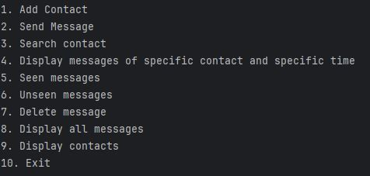

1. A screenshot of a computer

   Description automatically generatedAdd contact
2. 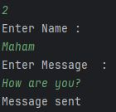Send Message
3. Search contact

1. Display all contacts

1. Non static block

